Azure

* Azure Emulator : its a local windows emulator to build and test applications before deploying.
* Linux login without password : we should map key vault mapping to any azure admin VM  
  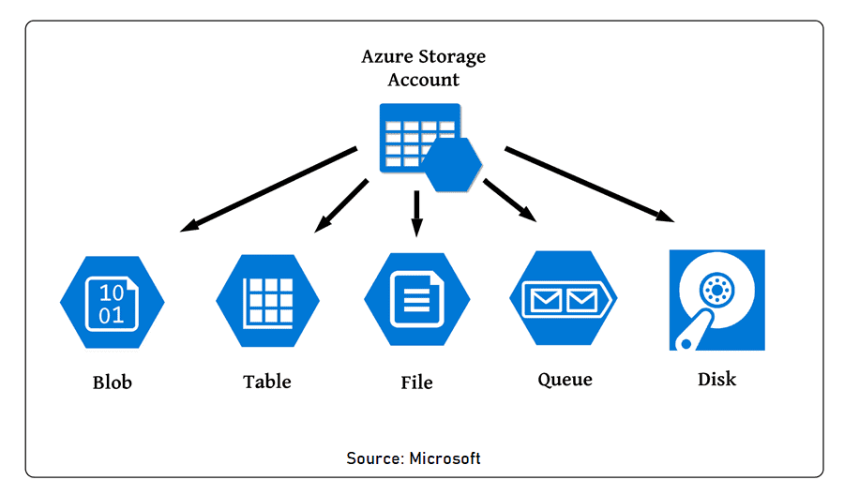
* Azure storage keys :: used for the authentication and validation of azure storages  
   Primary storage key : (in storage access keys blade) Key1  
   Secondary storage key : (in storage access keys blade) Key 2
* Azure storage Explorer : Free microsoft tool to manage Blobs and to modify and alter the data.  
  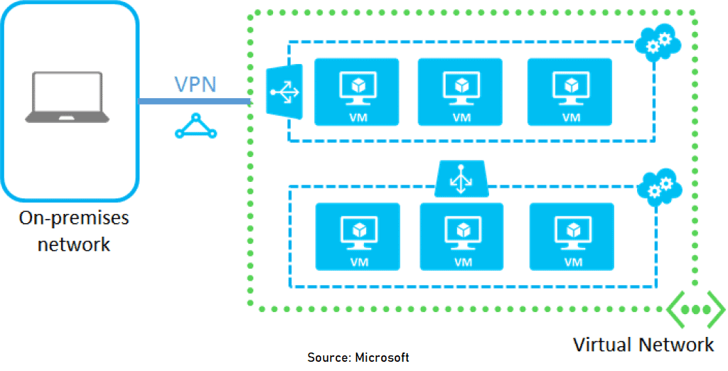
* Azure AD Connect : which is used to connect the onprem Ad and the azure ad
* AD vs AAD : Primary diff is the additional security (MFA) SSPassword reset.
* MFA : its an additional authentication process Call,SMS,Authenticator app, OATH software token.  
   Azure RBAC  
  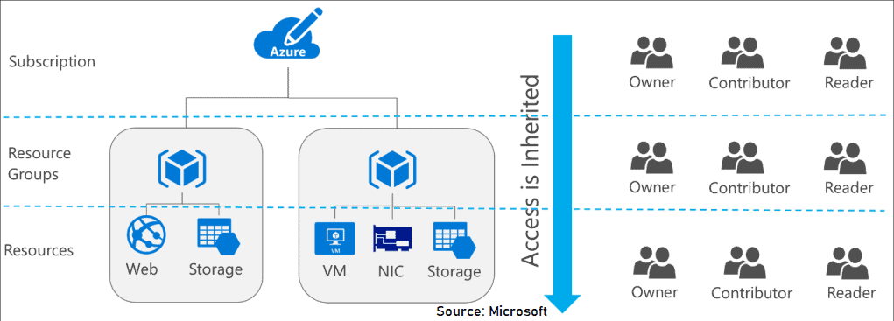
* Azure Policy : Policies are sets of rules that specify what can and cannot be created in either a single resource group or a full subscription.  
  